**TASK -6**

**1. Python Program to Find LCM**

**PROGRAM**

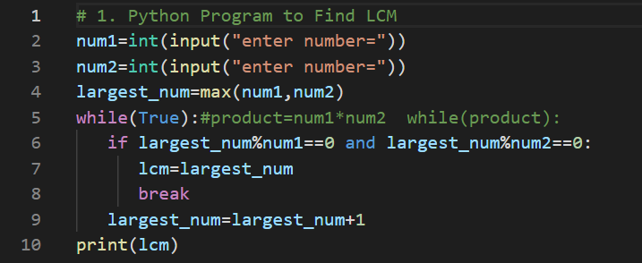

**OUTPUT**

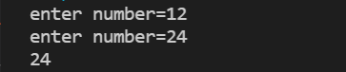

**2. Python Program to Find HCF**

**PROGRAM**

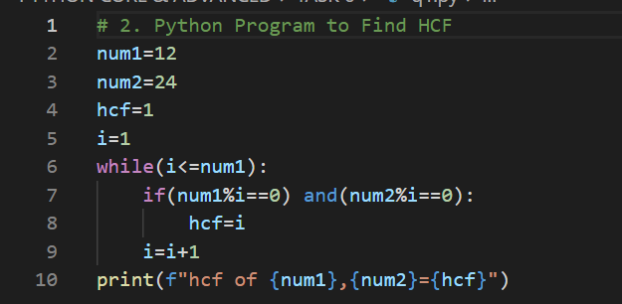

**OUTPUT**

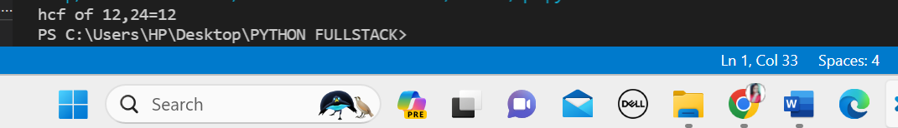

**3. Python Program to Make a Simple Calculator**

**PROGRAM**

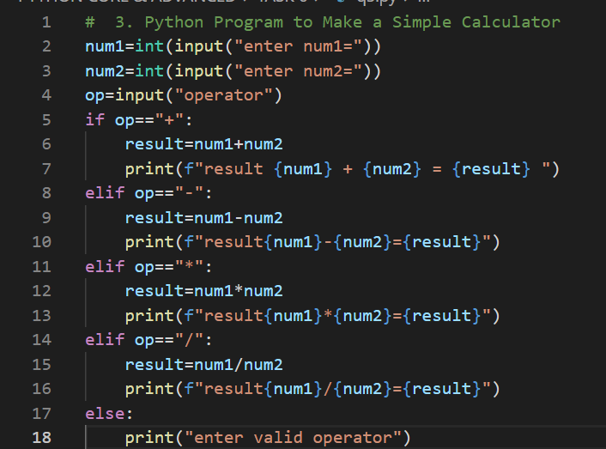

**OUTPUT**

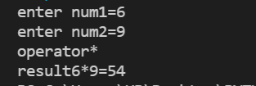

**4. Python Program to Find Factorial of Number Using Recursion**

**PROGRAM**

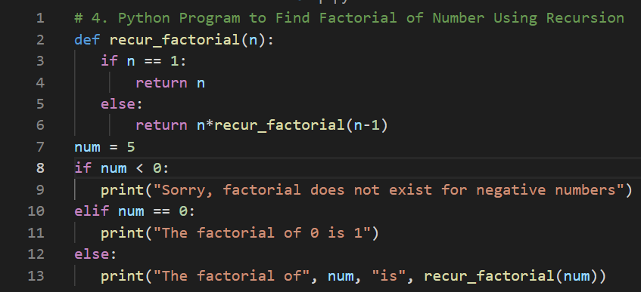

**OUTPUT**



**5. Python program to check if the given number is a Disarium Number**

**PROGRAM**

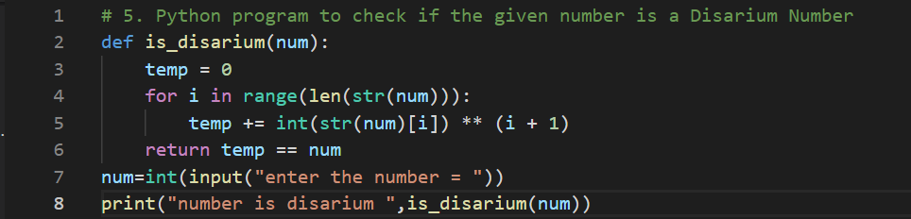

**OUTPUT**

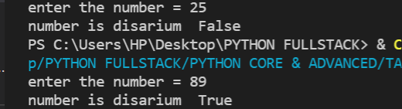

**6. Python program to determine whether the given number is a Harshad Number**

**PROGRAM**

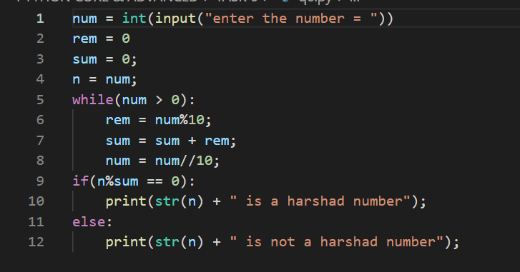

**OUTPUT**

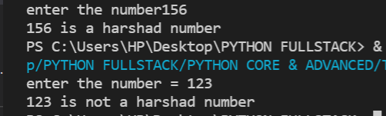

**7. Python program to check the number of digits present in a integer**

**PROGRAM**

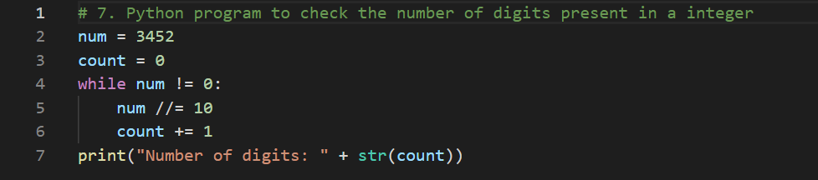

**OUTPUT**



**8. How to count the number of upper and lowercase letters in a string**

**PROGRAM**

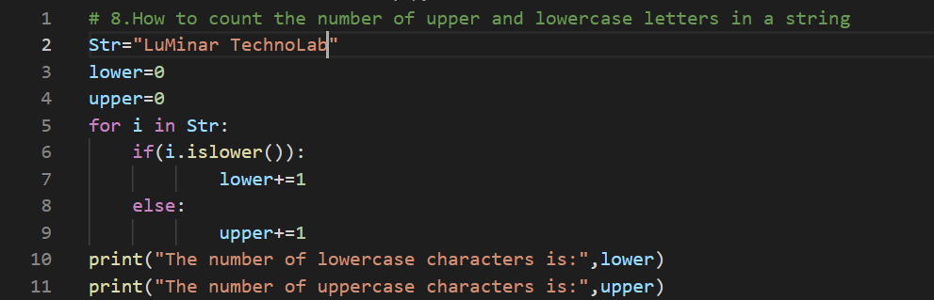

**OUTPUT**



**9. Write a program to count words in string**

**PROGRAM**

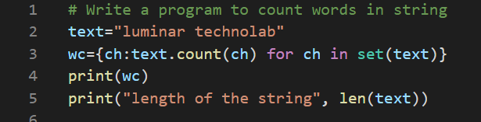

**OUTPUT**



**10. Write the program to find the lists consist of at least one common element.**

**PROGRAM**

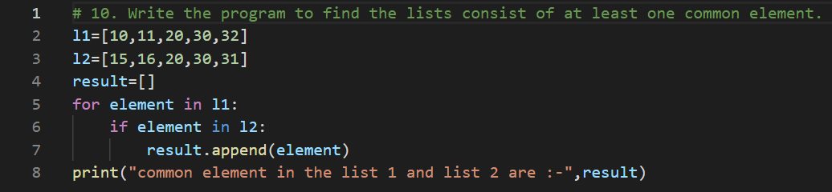

**OUTPUT**



**11. Python program to print the duplicate elements of an array**

**PROGRAM**

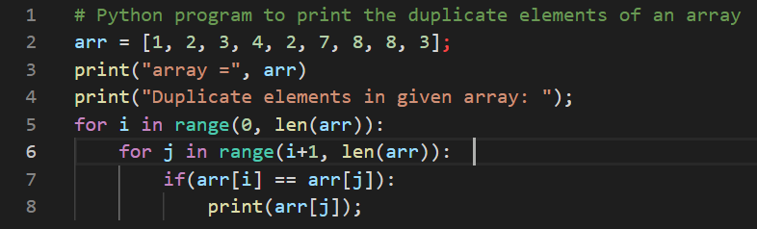

**OUTPUT**

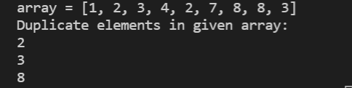

**12. Python program to print the elements of an array present on even position**

**PROGRAM**

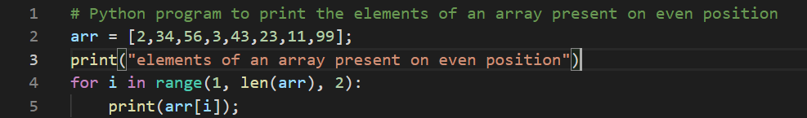

**OUTPUT**

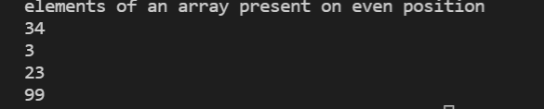

**13. Python program to print the elements of an array present on odd position**

**PROGRAM**

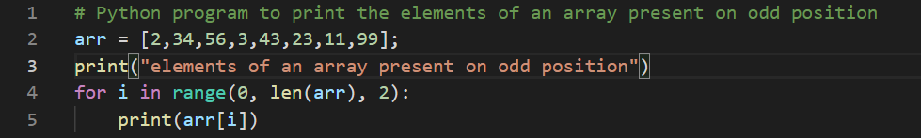

**OUTPUT**

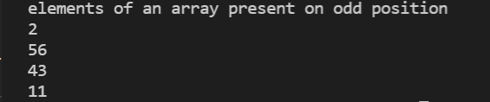

**14. Python program to print the largest element in an array**

**PROGRAM**

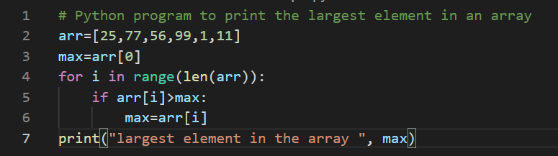

**OUTPUT**



**15. Python program to print the smallest element in an array**

**PROGRAM**

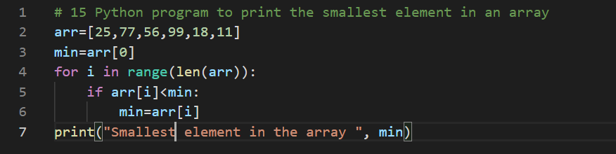

**OUTPUT**



**16. Python program to print the number of elements present in an array**

**PROGRAM**

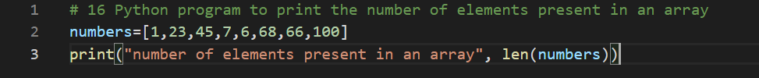

**OUTPUT**



**17. Python program to print the sum of all elements in an array**

**PROGRAM**

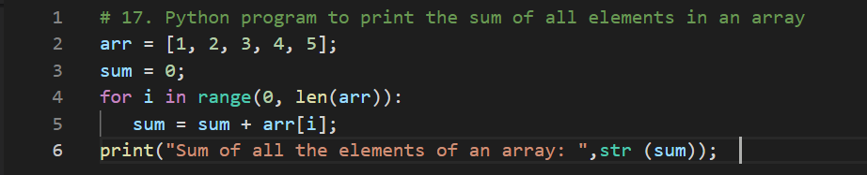

**OUTPUT**



**18. Python Program to Find Armstrong Number in an Interval**

**PROGRAM**

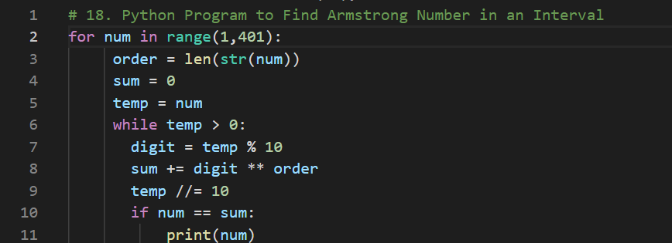

**OUTPUT**

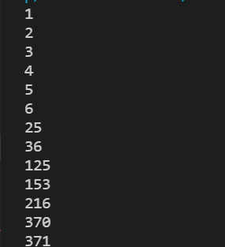

**19. Program to Check Armstrong Numbers in Python**

**PROGRAM**

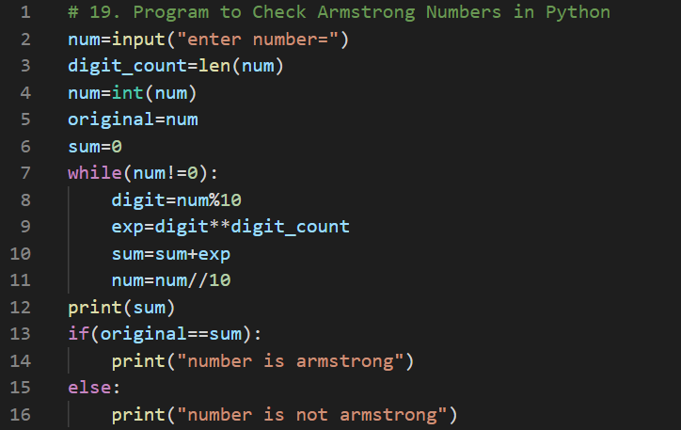

**OUTPUT**

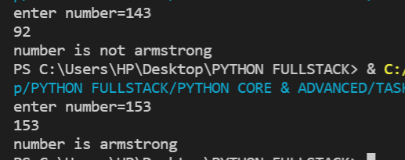

**20. Write a Python program to reverse a string.**

**PROGRAM**

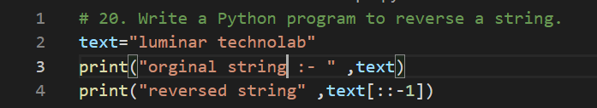

**OUTPUT**



**21. Write a Python program to check if a list is empty or not.**

**PROGRAM**

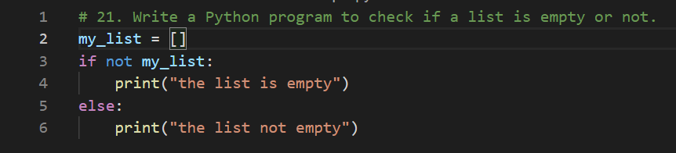

**OUTPUT**



**22. Write a Python program to multiply all the items in a list.**

**PROGRAM**

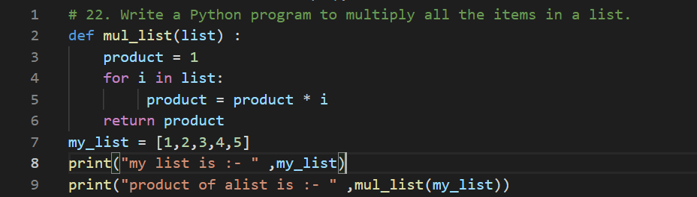

**OUTPUT**



**23. Write a Python program to clone or copy a list.**

**PROGRAM**

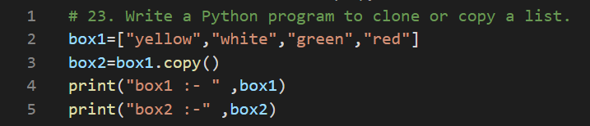

**OUTPUT**



**24. Write a Python program to print the numbers of a specified list after removing even numbers from it.**

**PROGRAM**

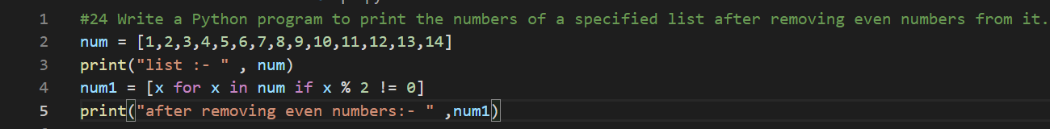

**OUTPUT**

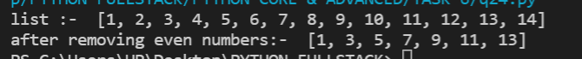

**25. Write a Python program to shuffle and print a specified list.**

**PROGRAM**

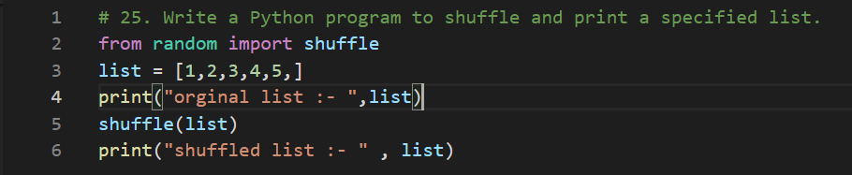

**OUTPUT**

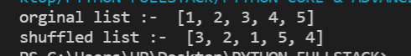

**26. Write a Python program to create a list with infinite elements.**

**PROGRAM**

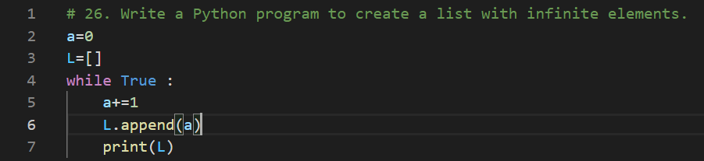

**OUTPUT**

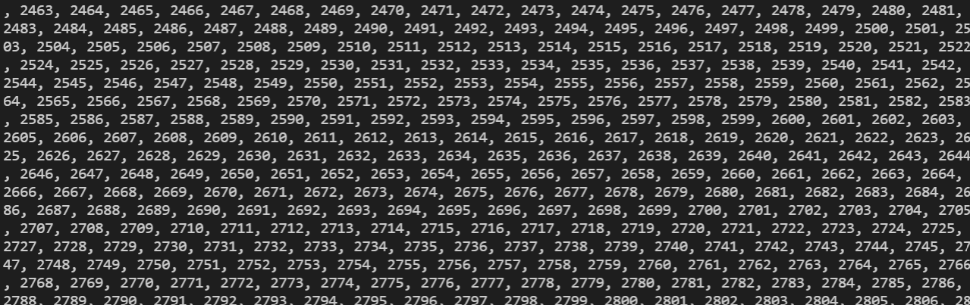

**27. Write a Python program to check whether the n-th element exists in a given list.**

**PROGRAM**

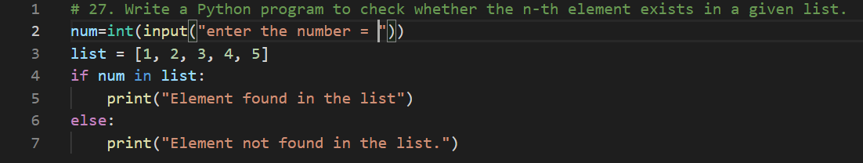

**OUTPUT**

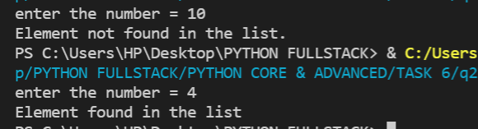

**28. Write a Python function to find the maximum of three numbers.**

**PROGRAM**

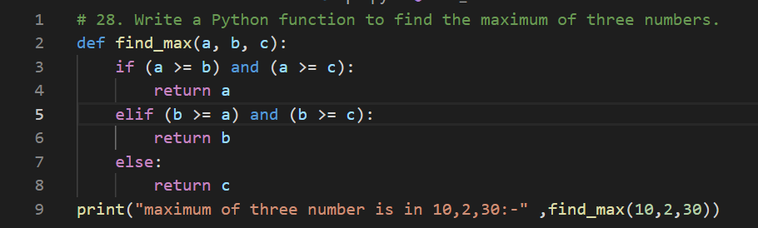

**OUTPUT**



**29. Write a Python function that accepts a string and counts the number of upper- and lower-case letters.**

**PROGRAM**

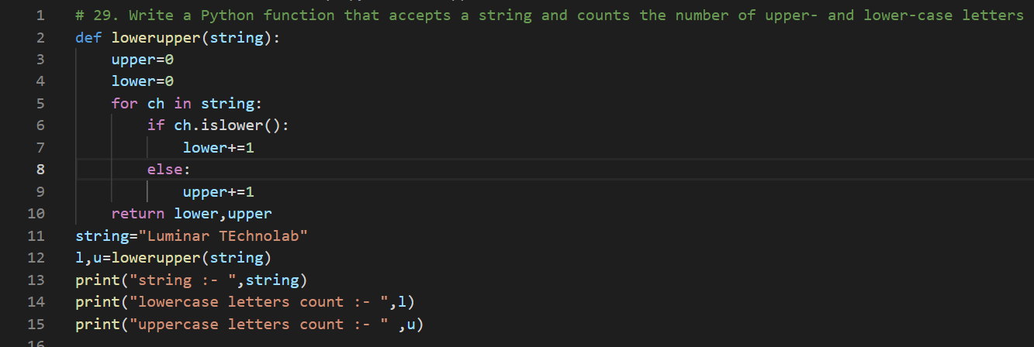

**OUTPUT**

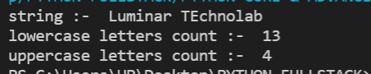

**30. Write a Python program to reverse the order of the items in the array.**

**PROGRAM**

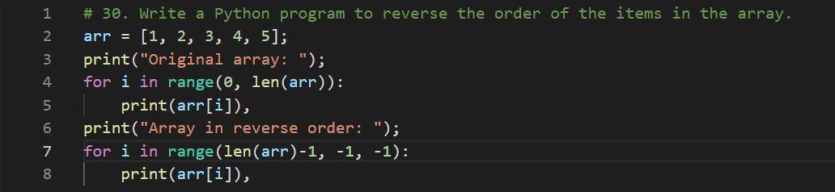

**OUTPUT**

